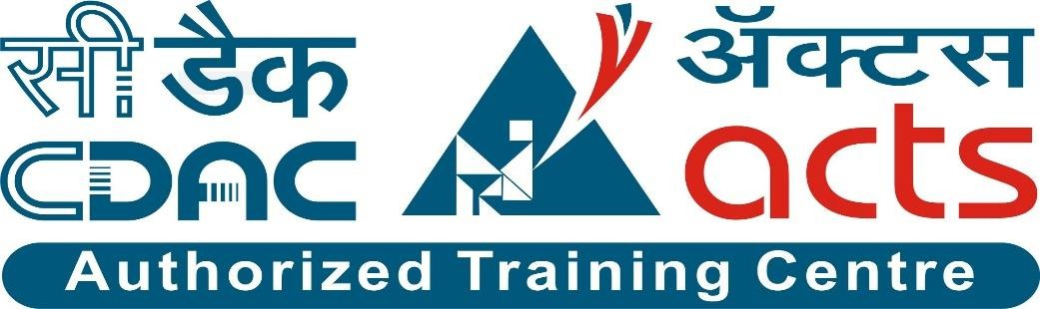

Project Name: “Social Issue Management System”

Branch PG-DAC FEB-2025

#### Documentation On

**“Social Issue Management System”**

#### PG-DAC February 2025

**Guided By: Bakul Joshi**

#### Submitted By:

**Group No: 19**

* **Harshvardhan Dhole** **250243020036**
* **Kshitij More** **250243020057**
* **Parag Suryavanshi 250243020061**
* **Soham Tanavade** **250243020098**

**Table of Contents**

1. Introduction 1
   1. Document Purpose 1
   2. Project Background 1
   3. Aim & Objective 1
   4. Customers and Stakeholders 1
2. Business Requirements Overview 2
3. Functional Requirements Overview 2
   1. Admin Module 2
   2. User Module 2
   3. Trainer Module 3
   4. Message Acknowledgement Module 3
4. Non-Functional Requirement 3
5. Use Case Diagram 4
6. Database Design 7
7. Snapshots: 11
8. Conclusion 24

# Introduction

### Document Purpose

This document outlines the business requirements and scope for developing a web-based Social Issue Management System (SIMS). The goal is to define the system's features, functionalities, and constraints necessary to provide a robust platform for citizens to report civic issues and for authorities to manage and resolve them efficiently. The document captures the functional and non-functional requirements, business rules, and other constraints to ensure successful design and implementation of the system.

### Project Background

With rapid urbanization and increasing population in cities and towns, civic issues such as garbage disposal, road damage, water leakage, streetlight faults, and drainage problems are growing in number and urgency. Citizens often lack a centralized and effective system to report these problems and track their resolutions.

This project addresses this challenge by providing a centralized online complaint management platform where citizens can raise issues, authorities can assign and resolve them, and admins can monitor and manage the system’s efficiency. The platform improves transparency, accountability, and responsiveness in public issue management.

### Aim & Objective

The aim is to develop a user-centric web-based application for lodging, tracking, and resolving civic complaints, ensuring better governance and improved public satisfaction.

* Develop a modular, scalable, and secure web application using microservices architecture.
* Enable citizens to register complaints with relevant details such as area, category, and description.
* Allow real-time tracking of complaint status (e.g., In Progress, Resolved, Rejected).
* Enable operators to manage and resolve complaints assigned to their area of responsibility.
* Provide admins with control over area management, operator roles, and reporting dashboards.
* Implement JWT-based login system to ensure secure and role-based access.
* Maintain a centralized complaint history for citizens.
* Ensure smooth integration between services such as Login, Citizen, Operator, and Admin.
* Provide API documentation and external accessibility via Swagger/Postman.
* Collect and analyze feedback or suggestions from users for system improvement.

### Customers and Stakeholders

##### Customers:

* + General public and urban citizens facing public service issues in their area.
  + Civic-conscious individuals who want accountability in public utilities and maintenance.
  + Community representatives or local leaders coordinating issue redressal for a region.

##### Stakeholders:

* + Municipal corporations and local government authorities responsible for public services.
  + Complaint resolution operators (employees or partners) in charge of issue management.
  + Administrative authorities managing area-wise operator roles and analytics.
  + Software development team responsible for maintaining and enhancing the system.

## **Business Requirements Overview**

* Target platform: Web Application
* User interface: User-friendly, intuitive, and visually appealing interface.
* Monetization strategy: Freemium model with optional premium features or subscription plans

## **Functional Requirements Overview**

1. Admin Module
2. Citizen Module
3. Zone Operator Module

### Admin Module:

* The admin has full control of the system
* Admin can manage and monitor citizens and operators.
* Admin can manage zones, roles, permissions, and issue categories.
* Admin has access to system-wide analytics and logs
* Admin oversees the overall health of the complaint management system.

### Citizen Module:

* Citizen can register and create their own account.
* Citizens can publish complaints about issues such as drainage, potholes, lighting, etc.
* They are able to view the status of their submitted complaints.
* Citizens can view other complaints in their locality to avoid duplication.
* They can provide feedback.
* The system supports acknowledgment and communication back to the citizen

### Zone Operator Module:

* Zone Operators can login and access the system securely.
* They can view and monitor complaints in their assigned zone.
* Operators can update the complaint status in real time.
* They can generate and download zone-specific reports.

# Non-Functional Requirement

* The website should use professional design, look and feel and color scheme.
* Users will have no limitations for accessing the application through Internet. The portal being an internet application, it is difficult specify exact number of visitor or users. Hence, we will target the system to support between 5 and 10 million users on launch of phase 1.
* Being a public website, the site must follow general usability guidelines for menus, navigation, colors, links and other actions provided on the screens.
* The system should be designed in such a manner that user will be able to complete tasks in minimum number of steps.

# Use Case Diagram

##### Admin:

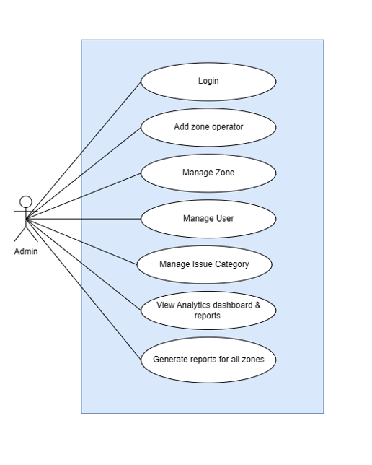

Admin:

* 1. In Admin use diagram Admin is the Actor
  2. Admin can handle the following use cases:
     1. Login
     2. Manage zone operator
     3. Manage issue category
     4. Manage zone
     5. Manage user
     6. View analytics dashboard & reports
     7. Report Generation

##### Citizen:

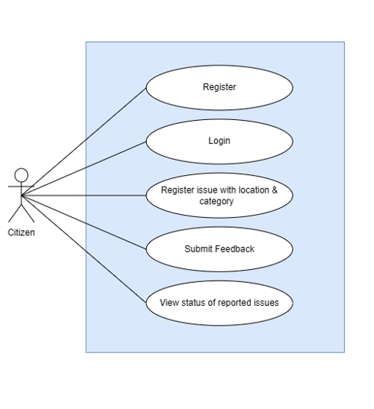

Citizen:

* 1. In Citizen use case diagram Citizen is the Actor.
  2. Citizen can handle following use cases:
     1. Register
     2. Login
     3. Register issue with location & category
     4. View other complaints in the area
     5. Submit Feedback
     6. View status of reported issue

##### Zone Operator:

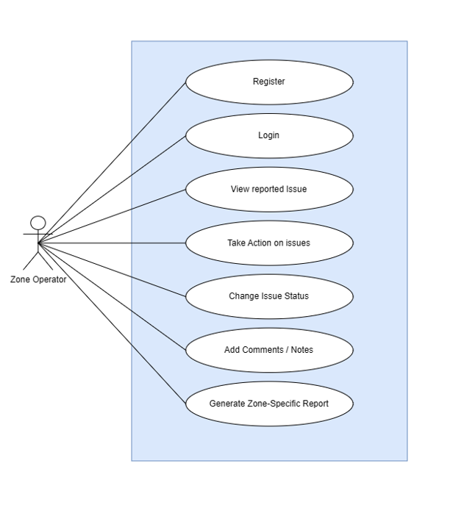

Zone Operator:

* 1. In Zone Operator use case diagram Zone Operator is the Actor
  2. Zone Operator can handle following use cases:
     1. Login
     2. View reported issue
     3. Take action on reported issue
     4. Change issue status
     5. Add comments \ Remark
     6. Generate zone – specific Report

# Database Design

##### Roles Table

|  |  |  |  |  |  |
| --- | --- | --- | --- | --- | --- |
| **Roles** | | | | | |
| **Field** | **Type** | **Null** | **Key** | **Default** | **Extra** |
| rid | INT | No | PK |  |  |
| rname | VARCHAR (45) | No |  |  | Unique |

##### Users Table

|  |  |  |  |  |  |
| --- | --- | --- | --- | --- | --- |
| **Users** | | | | | |
| **Field** | **Type** | **Null** | **Key** | **Default** | **Extra** |
| uid | INT | No | PK |  | Auto_Increment |
| uname | VARCHAR (45) | No |  | NULL | Unique |
| password | VARCHAR (200) | No |  | NULL | Unique |
| rid | INT | No |  | NULL |  |
| active | INT | No |  | 1 |  |
| phone_no | VARCHAR(255) | No |  |  | Unique |
| email | VARCHAR(255) | No |  |  |  |

##### Admin Table

|  |  |  |  |  |  |
| --- | --- | --- | --- | --- | --- |
| **Admins** | | | | | |
| **Field** | **Type** | **Null** | **Key** | **Default** | **Extra** |
| admin_id | INT | No | PK |  | Auto_Increment |
| fname | VARCHAR (45) | No |  | NULL |  |
| lname | VARCHAR (45) | No |  | NULL |  |
| dob | DATE | No |  | NULL |  |
| gender | VARCHAR (45) | No |  | NULL |  |
| contact | VARCHAR (45) | No |  | NULL |  |
| email | VARCHAR (45) | No |  | NULL |  |
| address | VARCHAR (45) | No |  | NULL |  |
| user_id | INT | No |  | NULL |  |

##### Area Table

|  |  |  |  |  |  |
| --- | --- | --- | --- | --- | --- |
| **Area Table** | | | | | |
| **Field** | **Type** | **Null** | **Key** | **Default** | **Extra** |
| area_id | INT | No | PK |  | Auto-Increment |
| area_name | VARCHAR(50) | No |  |  |  |
| pincode | VARCHAR(50) | No |  |  |  |

##### Issue Table

|  |  |  |  |  |  |
| --- | --- | --- | --- | --- | --- |
| **Issue Table** | | | | | |
| **Field** | **Type** | **Null** | **Ke y** | **Default** | **Extra** |
| issue_id | INT | No | PK |  | Auto_Increment |
| description | VARCHAR(80) | No |  | NULL |  |

##### Complaint Table

|  |  |  |  |  |  |
| --- | --- | --- | --- | --- | --- |
| **Complaint Table** | | | | | |
| **Field** | **Type** | **Null** | **Key** | **Default** | **Extra** |
| complaint_id | INT | No | PK |  | Auto_Increment |
| cid | INT | Foreign Key |  |  |  |
| issue_id | DATE | Foreign Key |  | NULL |  |
| area_id | INT | Foreign Key |  | NULL |  |
| description | VARCHAR(200) |  |  | NULL |  |
| submitted_at | DATE |  |  |  |  |

##### Complaint_Status Table

|  |  |  |  |  |  |
| --- | --- | --- | --- | --- | --- |
| **Complaint_Status Table** | | | | | |
| **Field** | **Type** | **Null** | **Key** | **Default** | **Extra** |
| complaint_id | INT |  | Foreign Key |  |  |
| status | VARCHAR(100) |  |  |  |  |
| updated_by | VARCHAR(200) |  |  | NULL |  |
| handled_by | VARCHAR(200) |  |  | NULL |  |
| note | VARCHAR(200) |  |  | NULL |  |

# Snapshots:

##### Home Page:

Following snapshot shows the **Home Page** ‘Social Issue Management System’ before Login.

user can navigate to Registration and Login page from Home Page.

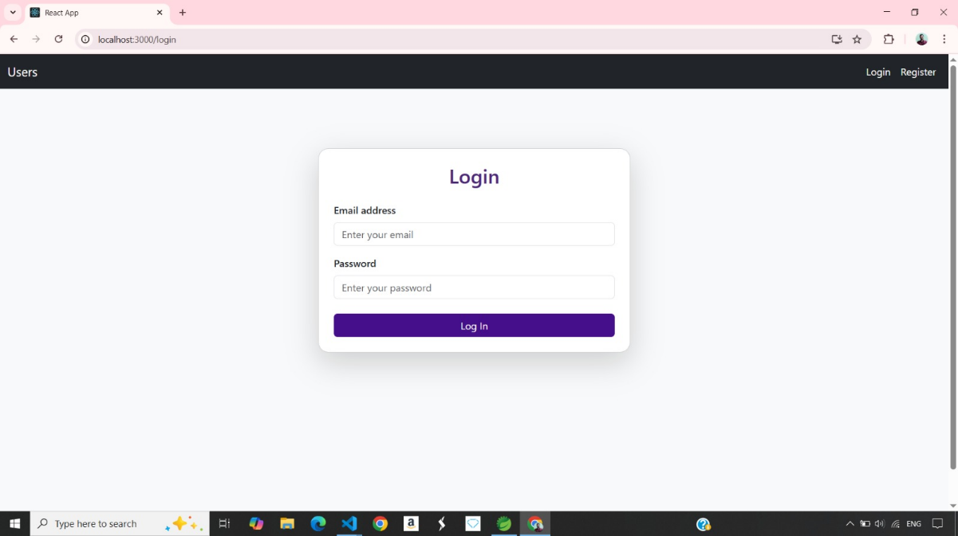

##### Registration Page:

Citizen can register himself by navigating to registration page.

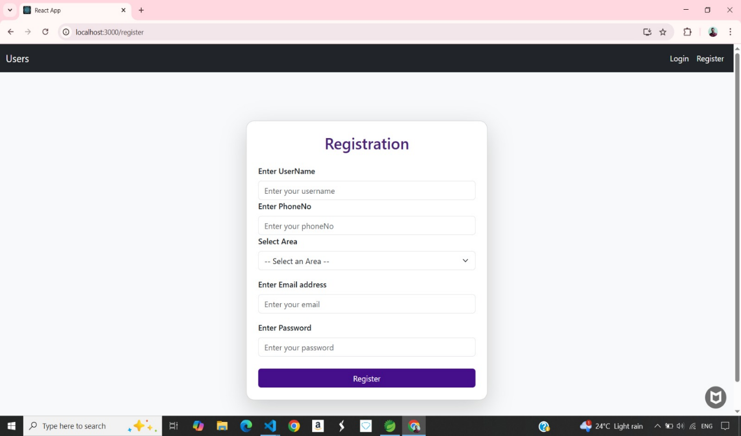

* 1. **Login Page:**

Citizen, Operator and Admin can login himself by navigating to login page



8.4 **Citizen Dashboard :**

Citizen can see all the complaints registered on website -

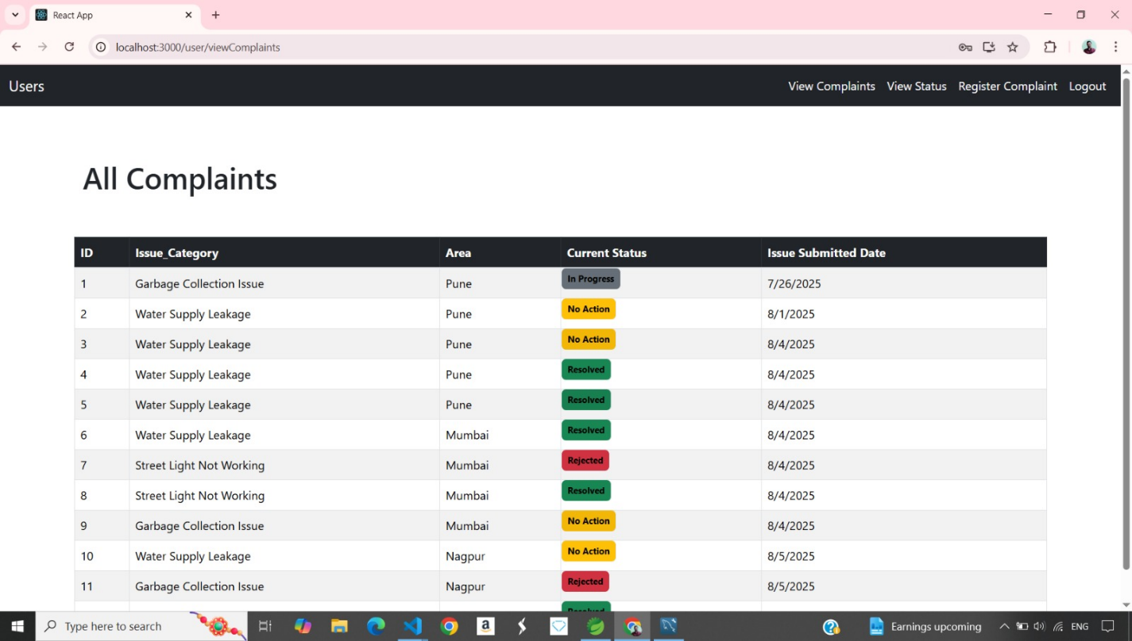

###### Citizen can also view the status of complaint registered by himself -

###### 

###### Citizen can register the new complaint on this platform –

###### 

* 1. **Operator Dashboard :**

###### Operator can view all the complaints with its status registered on platform,

###### He can simply filter the status wise as resolved, rejected, in progress and change the status when complaint get resolved –

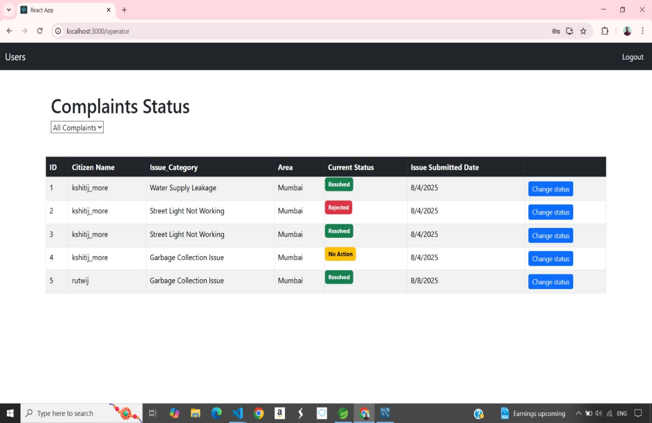

###### 

###### 

###### 

###### 

###### 

###### 

###### 

###### 

* 1. **Admin Dashboard :**

Citizen can see all the complaints registered on website -

###### 

###### 

###### 

###### 

Admin can add, edit or delete new Issue Categories to the platform -

###### .

###### 

###### 

###### 

Admin can also add, edit or delete new Area to the platform -

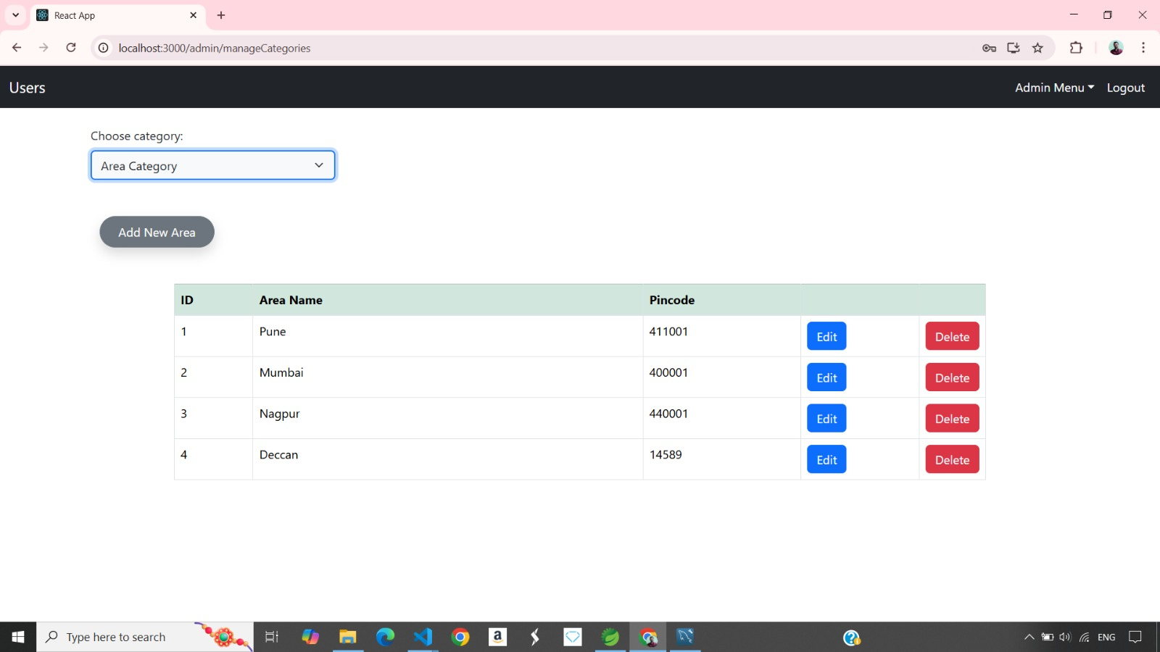

1. **ER Diagram**

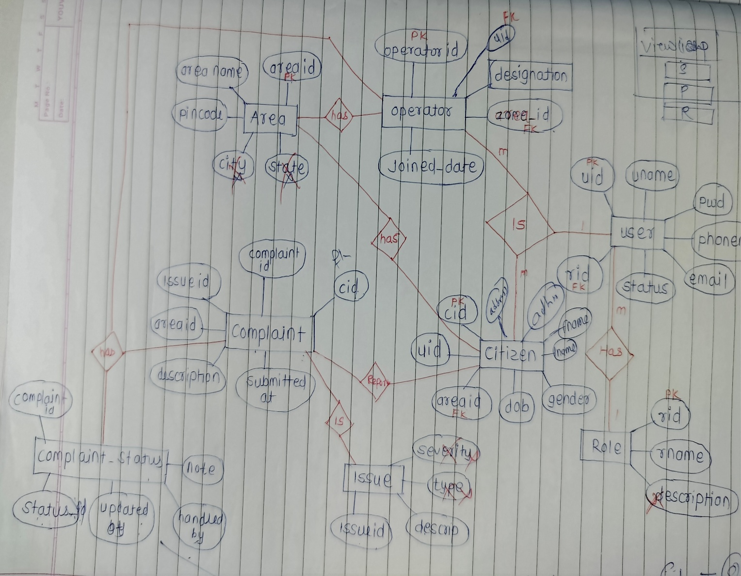

**Conclusion**

The “Calorie Coach” application aims to provide a comprehensive solution for individuals looking to improve their health and fitness. By combining fitness tracking and calorie tracking functionalities, the application targets fitness enthusiasts, individuals managing their weight, and athletes training for specific goals. With user-friendly interfaces, personalized guidance, and continuous improvement based on user feedback, the application seeks to be a valuable tool in promoting healthier lifestyles.